**Research Document: Design of Printboard for Teensy 4.0 with Serial Connection**

**1. Introduction** The goal of this research is to design a printboard for a Teensy 4.0 microcontroller with considerations for managing voltage levels in serial communication. The setup is part of the project Glow, which requires accepting data from five different tubes via serial connections and transmitting this data to a server using UDP Ethernet. The design must handle voltage level shifting between 5V Pro Micro outputs and the 3.3V-compatible Teensy 4.0 to ensure safe and effective operation.

**2. Components Overview** The essential components required for the design of the printboard include:

* **Teensy 4.0**: A powerful microcontroller running at 3.3V logic levels.
* **Pro Micro**: A microcontroller operating at 5V logic levels.
* **Resistors**:
  + 20kΩ resistors
  + 10kΩ resistors

**3. Voltage Level Shifting** Since the Pro Micro operates at 5V and the Teensy 4.0 at 3.3V, it is necessary to lower the voltage on the serial lines (Tx) to prevent damage to the Teensy. This can be accomplished using a simple resistor divider circuit.

**4. Resistor Divider Circuit Design** The voltage divider formula is used to calculate the output voltage:

* **Input Voltage (V_{in})**: 5V from the Pro Micro.
* **Target Output Voltage (V_{out})**: 3.3V for compatibility with the Teensy 4.0.
* **Chosen Resistors**:
  + **R1**: 20kΩ
  + **R2**: 10kΩ

Using these values:

This output voltage is safe for the Teensy 4.0’s 3.3V logic level.

**5. Component Connections**

* **Teensy 4.0**: Central microcontroller unit.
  + **Power/GND**: Connected to a stable power source.
  + **Ethernet Output**: Connected for communication as needed to send data to the server via UDP.
  + **Serial Inputs (5)**:
    - **Tx and Rx Lines**: Include voltage dividers to step down the voltage from the Pro Micro’s 5V outputs to 3.3V inputs.
    - **GND**: Common ground between Pro Micro and Teensy.

**6. Design Layout** The printboard layout should:

* Include space for the Teensy 4.0 and the associated resistor dividers.
* Ensure neat routing of serial connection traces (Tx, Rx) from Pro Micro units to the Teensy, incorporating the resistor dividers in the path.
* Designate separate lines for power and ground for clear signal integrity.
* Integrate Ethernet connections to facilitate data transmission to the server.

**7. Assembly Notes**

* **Soldering Tips**:
  + Resistors should be soldered firmly without cold joints to maintain signal consistency.
  + Verify connections with a multimeter for continuity and correct voltage output.
* **Testing**:
  + Power up the setup without the Teensy initially to test voltage outputs on the serial lines.
  + Confirm that the voltage does not exceed 3.3V on the Teensy input pins.

**8. Conclusion** By using the chosen resistor values (20kΩ and 10kΩ), the voltage on the serial connection can be safely stepped down from 5V to 3.3V, ensuring compatibility between the Pro Micro and Teensy 4.0. Proper assembly and layout will result in a reliable printboard for serial communication, capable of processing data from five tubes and sending it to the server via UDP Ethernet.

This research and design framework will guide the development of a secure and efficient printboard suitable for serial communication between the specified microcontrollers for the Glow project.

Attachment 1:

Pinout teensy.

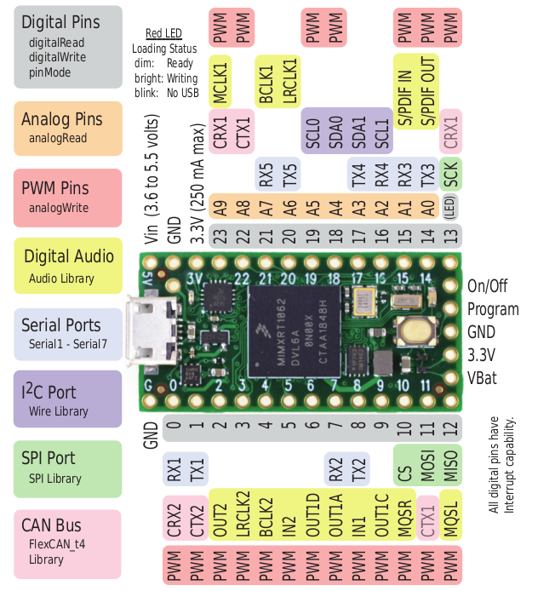

Attachment 2:

Pinout w5500 ethernet module.

